Question 1
Figure 1: Reservoir and pump system sketch.

The pump shown in Figure 1 is used to pump water from one open reservoir up to another open
reservoir for storage. The top surface of the upper reservoir is located 45 m above the top surface
of the bottom reservoir and is fed by a 90 m long, 80 cm diameter pipe. The ow rate through
the pipe is held at a constant 4.0 m3/s. The frictional losses through the pipe can be computed
using the equation
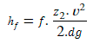
Where$f$ is a dimensionless loss factor (obtain with Haaland equation or Moody chart, using
$\frac{∈}{D}$= 0.001
Assuming negligibly small minor losses (entry and exit and elbows) and the pump operates with an eﬃciency of 86 %, what is the required input power to run the pump?

Answer of Question 1
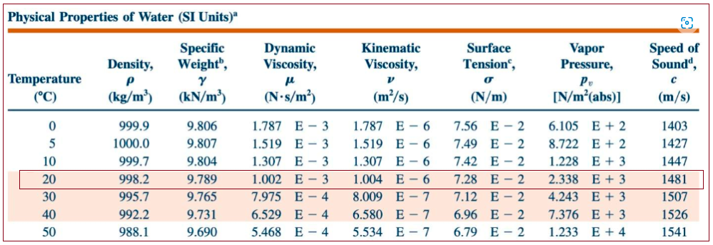
At 20 degree temperature;
- Density of water = ρ = 998.2 𝑘𝑔/𝑚³
- Dynamic viscosity of Water = µ = 0.0010020 𝑘𝑔𝑚/𝑠.
Pipe's Internal Diameter = d = 0.8 m
Velocituy of the Fluid denoted by 'v'
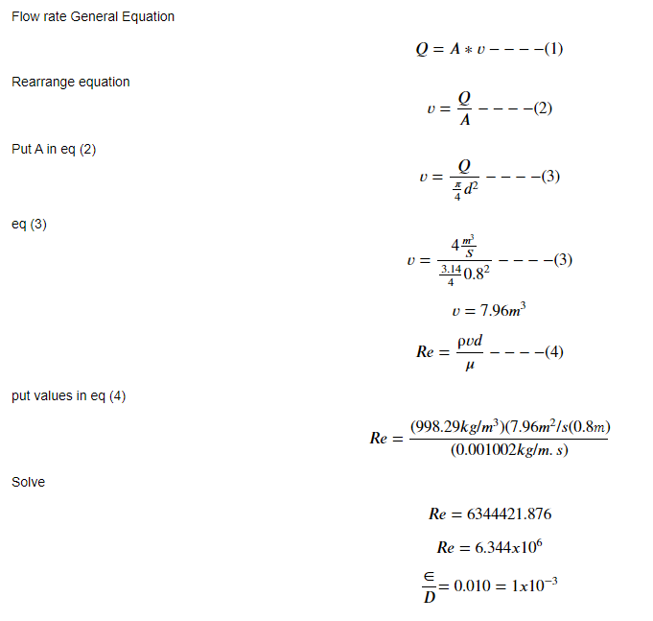
∈/D = 0.001

Check Moody’s Diagram Above: 𝑓≈0.01972
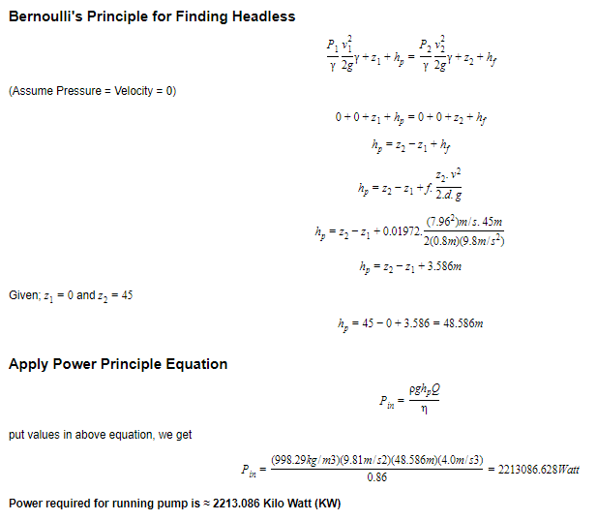

Question 2
Vapor in a multi-effect distillation plant such as the one shown in Figure 2 vapor can carry mist droplets with salt and other contaminants. To limit the amount of contaminants that reach the vapor exit (see arrow in the figure), we may want to control the speed of the vapor so that it can carry only the liquid droplets smaller than a certain size upwards.

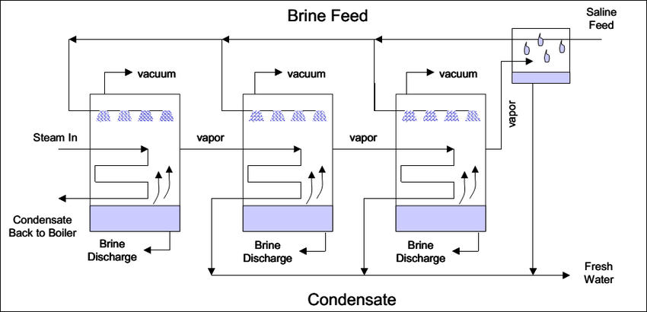

Question: If we have a vertical ow of saturated water vapor at 0.15 bar absolute pressure and we want to allow it to carry droplets with a maximum diameter of 120$μ$m, what is the maximum velocity at which the vapor can flow to not carry larger droplets?)

Assumptions and hints:

- Assume steam is saturated. Definition: Water heated to boiling point is vaporized and turns to saturated steam. If saturated steam is heated further (temperature above boiling point at given pressure), dry steam is generated and traces of moisture are gone (and in such case we have superheated steam).
- Assume droplet is spherical and can be treated as a rigid sphere a first approximation.
- Use the density and viscosity of liquid and vapor water at the appropriate saturation temperature. One reference for such properties can be found here: NIST - Thermophysical Properties of Fluid Systems.
- Hint: start with a force balance. Assume that droplet would need to travel vertically upward (towards the screen above).

Answer of Question 2

Rigid Sphere's Drag's Coefficient:-

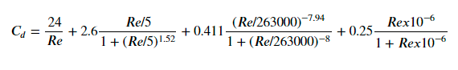
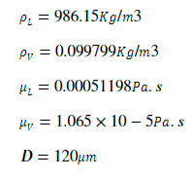

The Maximum velocity at which the vapor can flow to not carry larger droplets = 𝑈_𝑣 =?
Use Force Balance Formula to Calculate Required

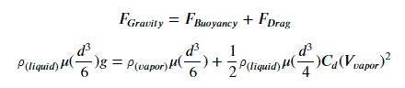

Simplify

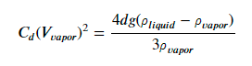

The Maximum velocity at which the vapor can flow is (𝑈_𝑣 =? )????

Python Code

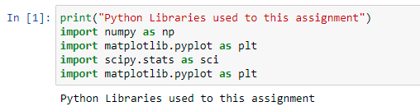

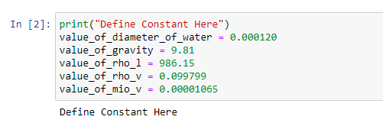

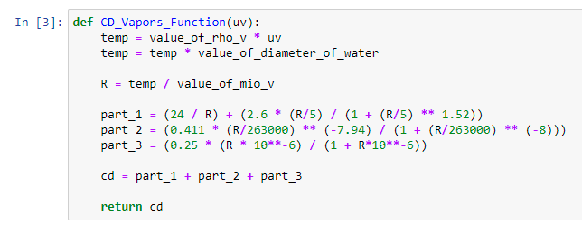

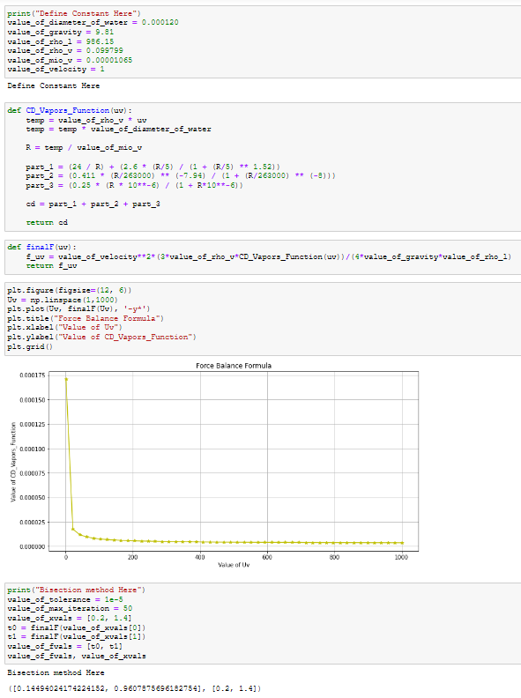
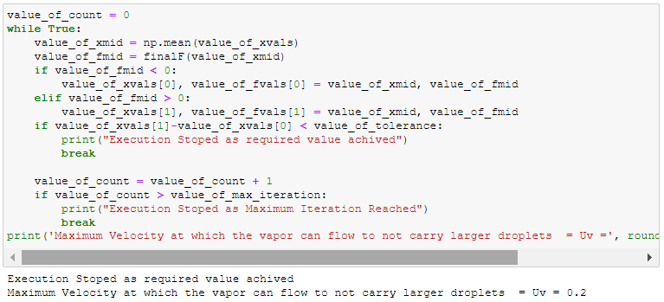

Maximum Velocity at which the vapor can flow to not carry larger droplets = Uv = 0.2

Question 3
To have a robust yet economical mass ﬂow rate measurement with a relatively low pressure loss, a venturi ﬂow meter may be utilized. Let us consider the performance and likelihood of cavitation in a horizontal venturi. We shall assume constant ﬂuid properties, and denote the contraction ratio as β, deﬁned as β = dthroat/dpipe. For a venturi, the mass ﬂowrate can be determined as a function of ﬂuid density, measured diﬀerential pressure ∆p = Ppipe – Pthroat and contraction ratio β.
(A) Sketch the venturi and label locations where you deﬁne pressures.
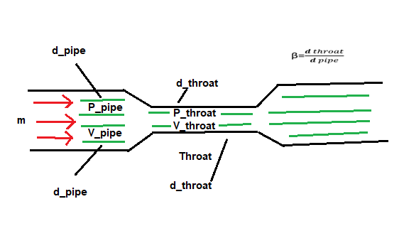

- velocities in the Equations:
- $\dot{m}=A_{throat}\sqrt{\frac{2ρ∆ρ}{1-β^{4}}}$
- $β=\frac{d_{2}}{d_{1}}<1$
- $∆ρ=ρ_{pipe}-ρ_{throat}>0$

B) As no instrument is perfect; from the lectures we recall that above equation needs to be multiplied by a discharge coeﬃcient. Assume it has a constant value of Cd = 0.965. Our venturi has β = 0.6 and Athroat = 0.003 m2. We shall assume that the uncertainty in density is 2 %, in area of throat 1 % and in β is 1 % for each, all with 95 % conﬁdence. If mass ﬂow rate of 25 kg/s is to be determined within 5 % with 95 % conﬁdence, what is maximum uncertainty allowable for the diﬀerential pressure measurement?
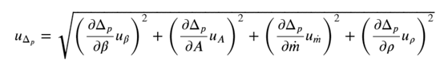

Answer 1 of Question 3

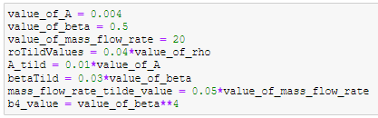

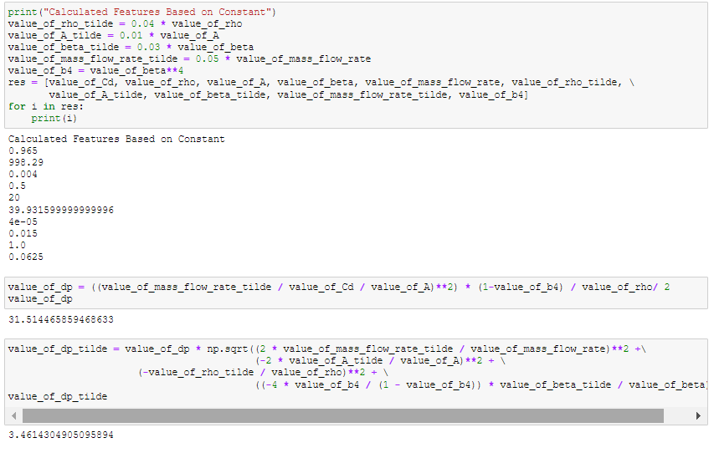

- ${\tilde{∆P}}_{mean}=$ 32509.85 Pa
- ${\tilde{∆P}}_{std. deviation}=$3384.06$Pa$
- Maximum uncertainty allow is $\frac{3384.06Pa}{32509.85 Pa}X100=10.40\%$

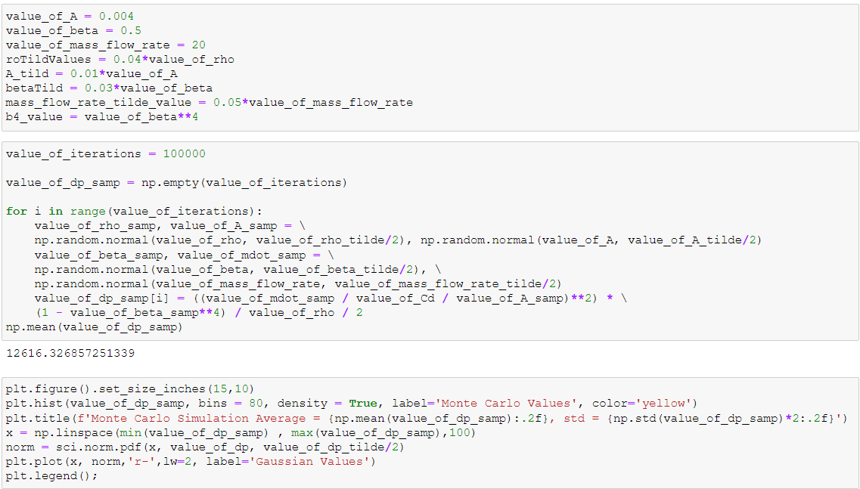
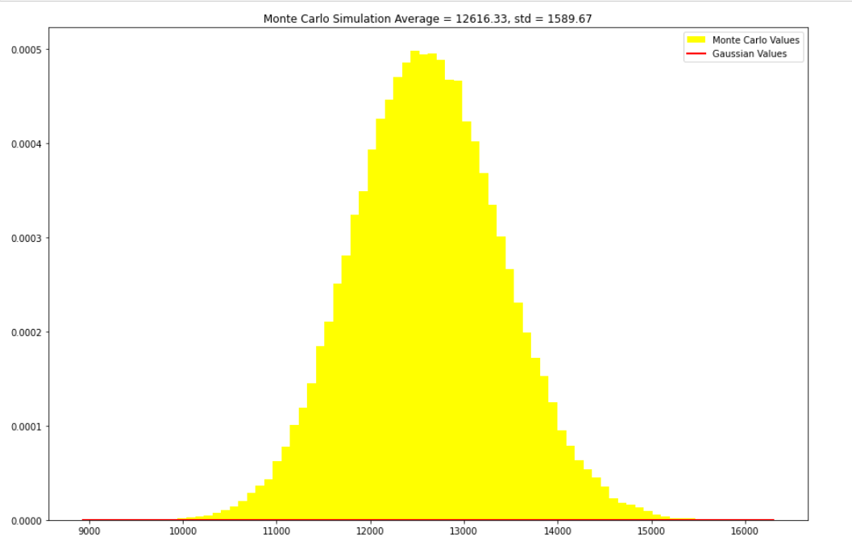
- ${\tilde{∆ρ}}_{mean}=$32531.12 $Pa$
- ${\tilde{∆ρ}}_{std. deviation}=$33241.77 $Pa$
- Maximum uncertainty allow is $\frac{33241.77Pa}{32531.12 Pa}X100=10.22\%$

(C) If cavitation inception is expected at $σ=\frac{ρ_{ref}-ρ_{vapor}}{\frac{1}{2}ρU_{ref}^{2}}≤1.8$, with cavitation number deﬁned based on ’reference’ pressure and velocity upstream of the throat. For the above ﬂow rate, what is minimum pressure allowed at the venturi inlet to likely avoid cavitation? Assume water temperature is 20 ◦C.
Hint: start by deﬁning the cavitation number and be consistent with labeling from part A.
- $σ=\frac{P-P_{vapor}}{\frac{1}{2}ρU_{ref}^{2}}≤1.8$
- $σ \frac{P_{pipe}-P_{vapor}}{\frac{1}{2}ρv_{pipe}^{2}}=1.8$
Solve for $v_{throat}$:
- $v_{throat}=\frac{\dot{m}}{ρA_{throat}}$
- $v_{throat}=\frac{25}{\left(998.29\right)\left(0.003\right)}$
- $v_{throat}=8.34 m/s$
Solve for $v_{pipe}$:
- $v_{pipe}=v_{throat} β^{2}$
- $v_{pipe}=\left(8.34\right){\left(0.6\right)}^{2}$
- $v_{pipe}=3.0m/s$
Minimum Allowed Pressure at Venturi Inlet to avoid Cavitation will be:-
$∴ P_{vapor}=2353$
$∴σ$=1.8 given from the question.
Solve $P_{pipe}$:
- $P_{pipe}=σ\frac{1}{2}ρv_{pipe}^{2}+P_{vapor}$
- $P_{pipe}=\left(1.8\right).\frac{1}{2} . ρ . v_{pipe}^{2}+P_{vapor}$
- $P_{pipe}=\left(1.8\right).\frac{1}{2} . (998.29) . {\left(3.0\right)}^{2}+2353$
- $P_{pipe}=8086.149+2353$
- $P_{pipe}=10439.149Pa ≈10.43KPa$

Question 4
Assume we have a 600 mm ID pipeline that is 300 m long supplying water to an older desalination plant at a mass ﬂow rate of 850 kg/s. Due to corrosion the average roughness of the pipe has increased to 5.5 mm, from the original 0.1 mm. Assume pumping eﬃciency of 82 %, electricity price of 0.11 USD/kWh. And, that you are pumping seawater at 20 ◦C.
Also note: the liner could also block leaks the pipeline may have had.
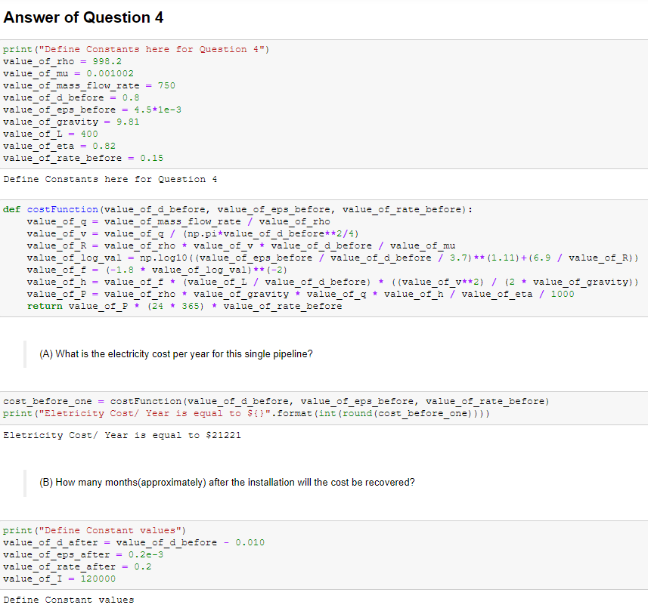
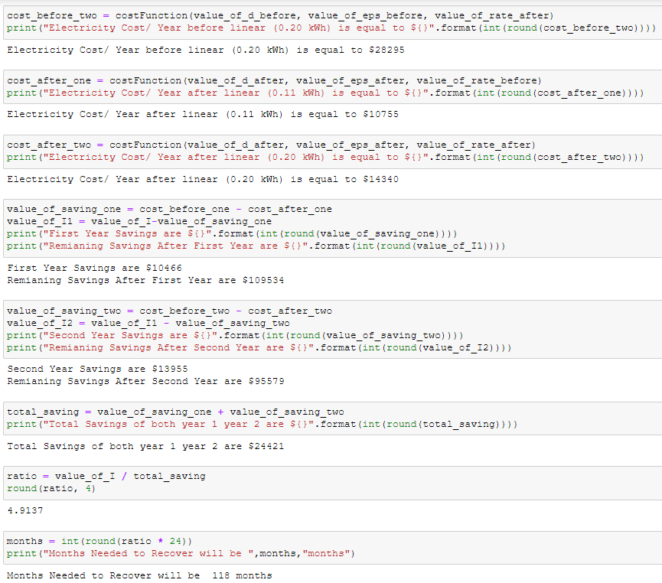
Question 5
All other things being equal, smoother pipe, larger diameter, more gradual pipe transitions etc. will lead to a reduced pressure drop in pipe network. And, ideally none of the components should be inﬂicted by cavitation. During the course we discussed pressure loss estimation based of textbook approaches, and calculations nowadays typically handled by commercial codes. For this assignment, you will examine a simple pipe network and study eﬀect of uncertainty to network performance using the Monte-Carlo method for uncertainty propagation.
Use a textbook approach (with friction factors e.g. from Moody diagram (Figure 6.13 in White) based on given roughness White (1998)) to simulate the performance the network should have. Note that simulated performance may deviate from measured performance not only due to uncertainty about initial dimensions of components, but also due to installation deviating from design (e.g. extra bends and rough welds), eﬀects of corrosion and fouling on roughness given age of pipeline, etc.
For a complex pipe network, commercial or freeware codes would typically be used to evaluate performance of the network. While the solution methodologies vary, the basic conservation laws remain unchanged. Hence, let us consider a simple example pipe network and a) write our own code to solve for the ﬂow rates, b) use WNTR simulation library in python to resolve the same network and ensure your answers match, and c) implement a Monte-Carlo solution.
Assume pipe diameters have uniform distribution between 98% and 103% of nominal diameter and roughness has an exponential probability distribution with mean being the listed value. Rerun the Monte Carlo simulation with water properties at 10◦C and 30◦C (in addition to the original design point of 20◦C) in order to evaluate the inﬂuence of temperature on system performance. NOTE: The WNTR simulation library in python will be used for comparison in

Figure 3: Pipe network to analyze. Figure adapted and modifed from Jeppson (1974), and the
values have been changed.

Answer of Question 5
a) Use whichever method you are most comfortable with (Linearized approach from lectures, Hardy-Cross, Newton-Rhapson, or other) to setup equations and then solve the ﬂow rates and pressures throughout the network. Start from conservation of mass and consider only the major losses for ∆p calculations(i.e. neglect minor losses due to ﬁttings and instruments).
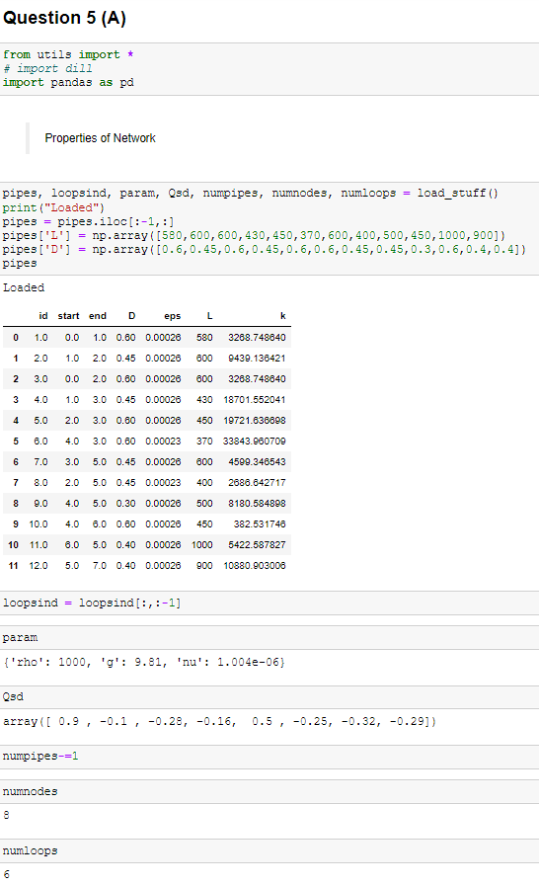
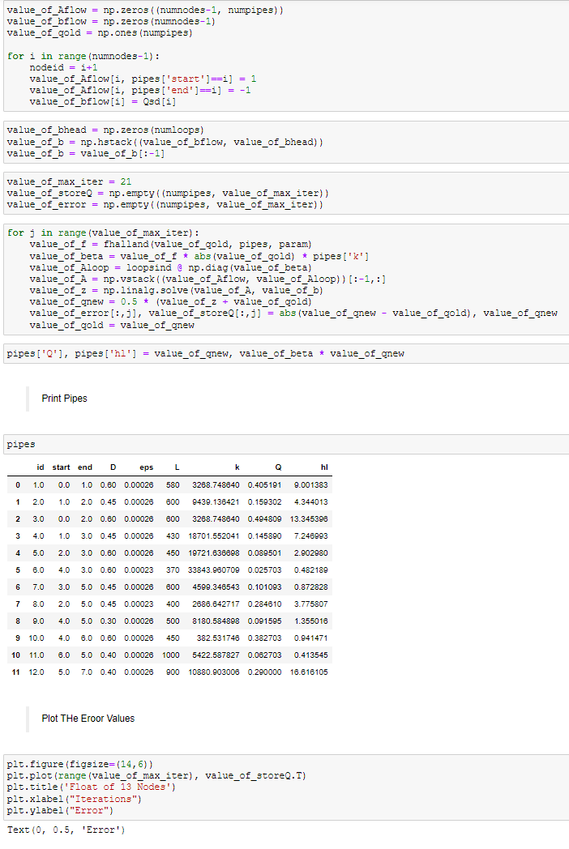

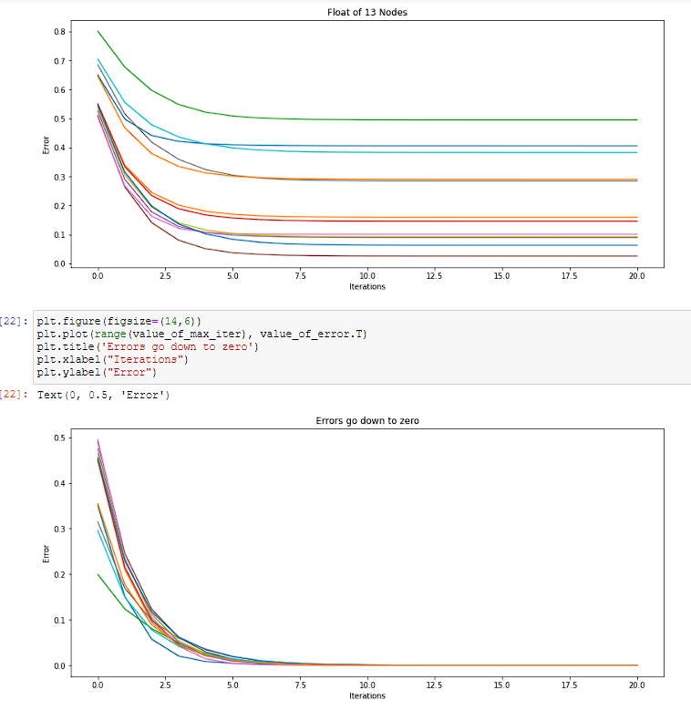

b) Assuming node [1] is at 200 kPa (gauge) and that water to supply nodes ([1], [5] and [7]) was delivered from open reservoirs at 0 kPa (gauge) by pumps that are 85% eﬃcient, how much energy (in kWh) per day is required to deliver the water (report for each pump)?

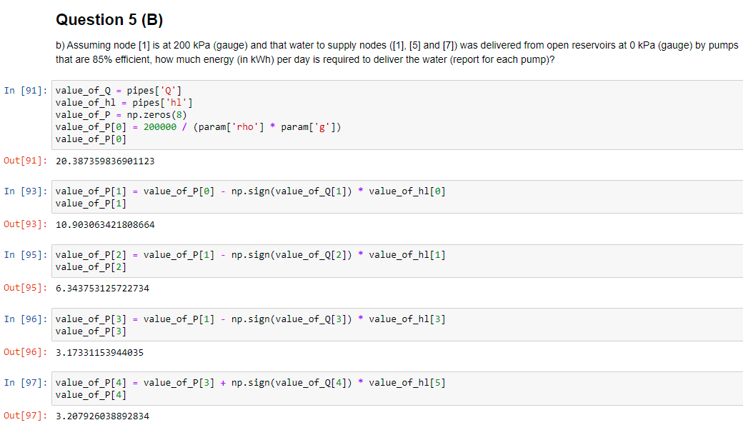
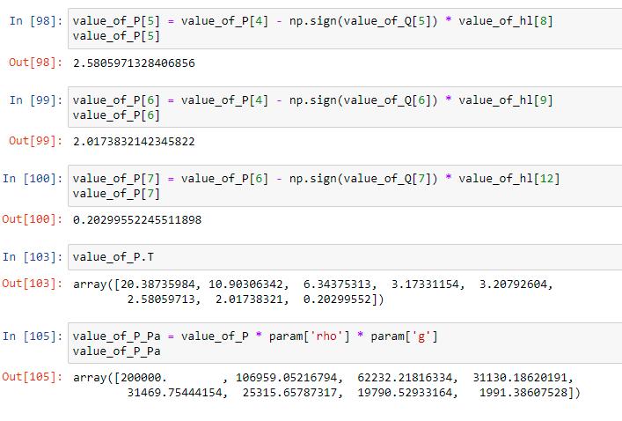
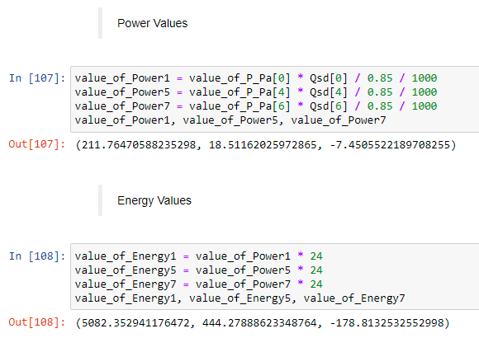
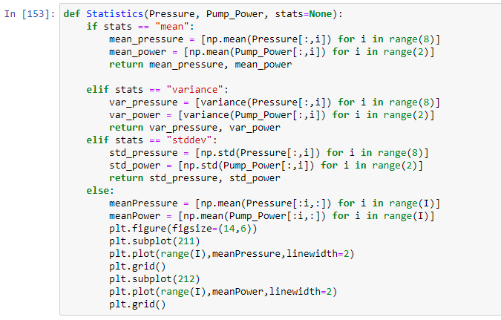
c)Use WNTR to check solution of part a. Report your results for ﬂow rates and pressures throughout the network.
Hint: WNTR requires at least one reservoir, so even though we know all of the ﬂowrates into the network, you will need to set one as a reservoir. WNTR will solve for the ﬂow from the reservoir into the network and you can check to conﬁrm that it matches the given value and mass is con-served. Also, make sure that all of your junctions and pipes have unique names.
Check point: To check your result, the ﬂowrate in pipe 2 should be approximately 0.160 m3/s and the head at node 3 should be approximately 6.3 m.

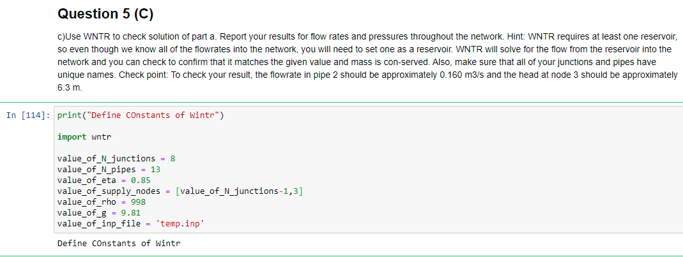
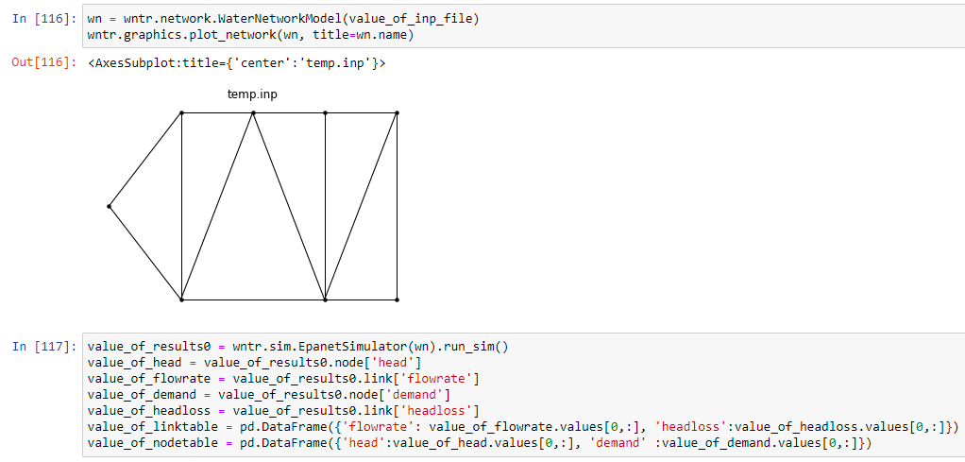
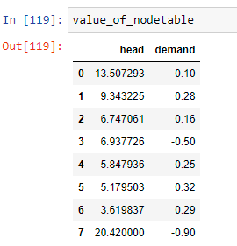

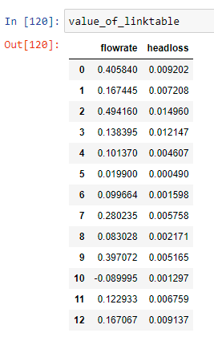
d) Use WNTR and estimate the eﬀect of uncertainty in pipe conditions of pumping power needed to supply network shown in ﬁgure 3. Use your code and Monte-Carlo method for propagating uncertainty and consider
i) uncertainty in pipe roughness,
ii) uncertainty in pipe length,
iii) uncertainty in pipe diameter (see table 1).
Perform a convergence study to show that you have run enough iterations for your results to have converged. To estimate uncertainty in roughness, use a normal distribution with the mean matching the nominal roughness and the standard deviation of 1/5 the mean. Report the uncertainties in pressure throughout the system based on your MC simulation as well as the uncertainty in required pumping power at the supply node 5.

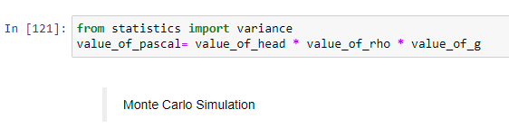
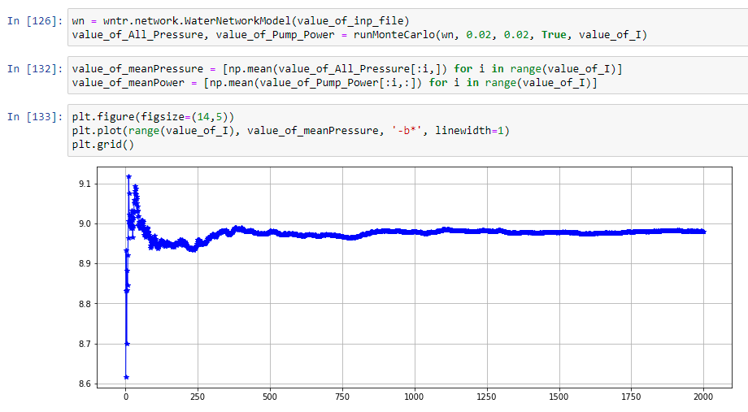
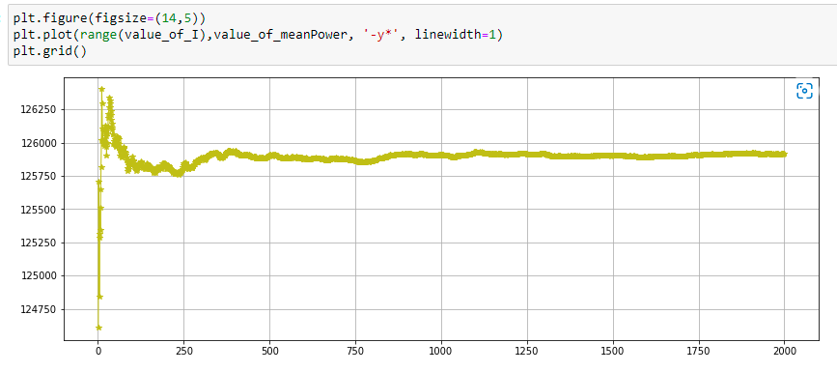
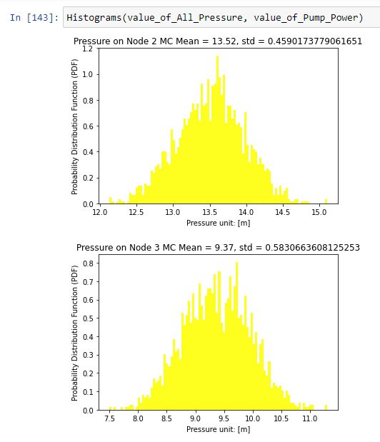

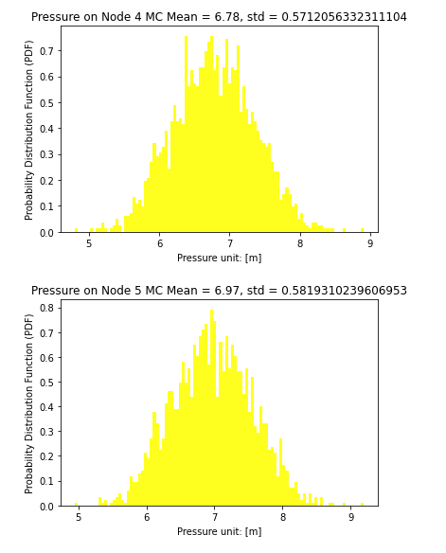

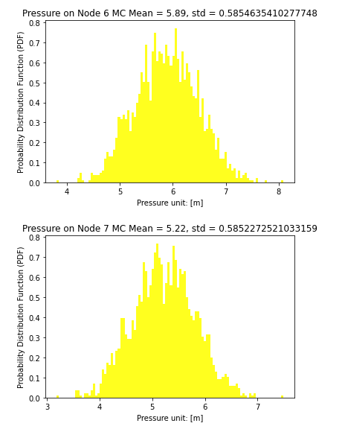

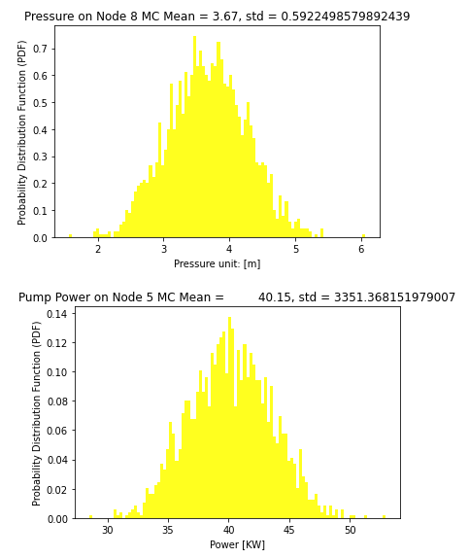

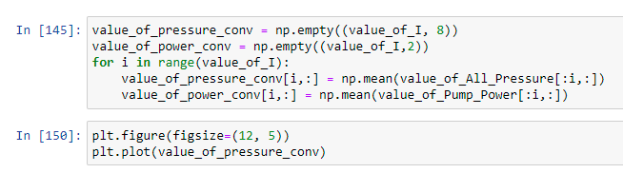
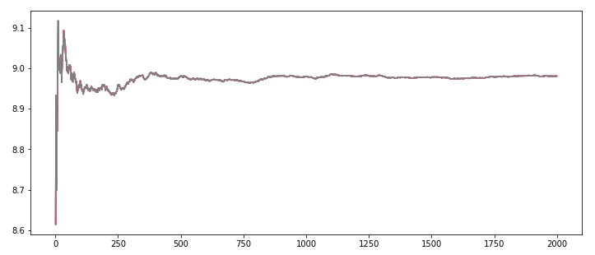
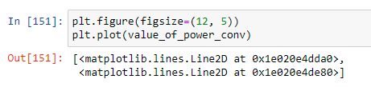
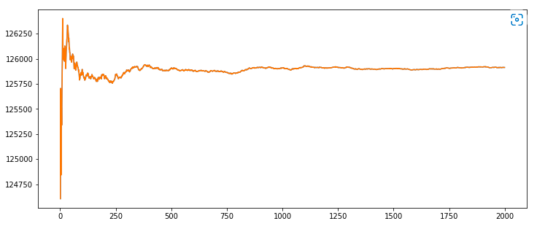
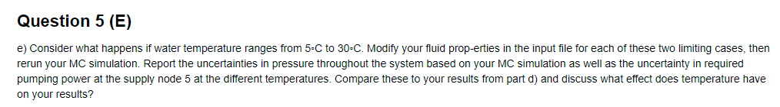
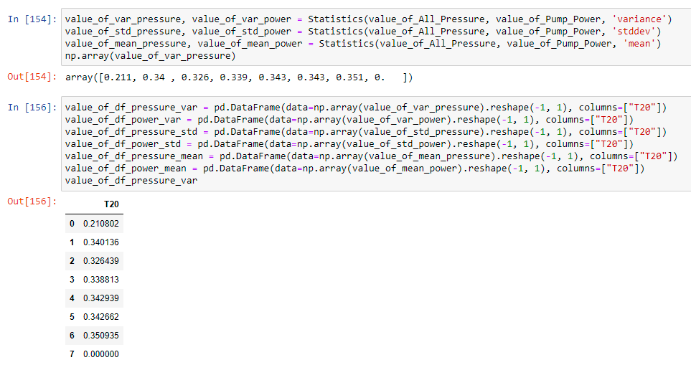
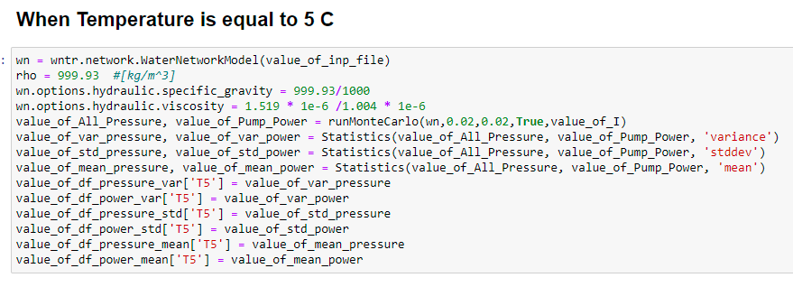
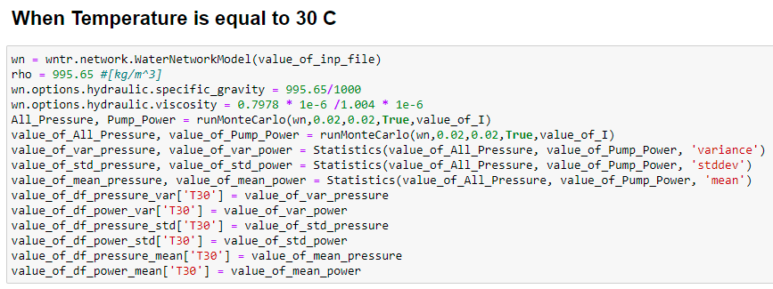
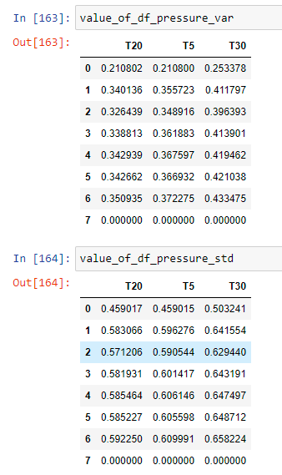
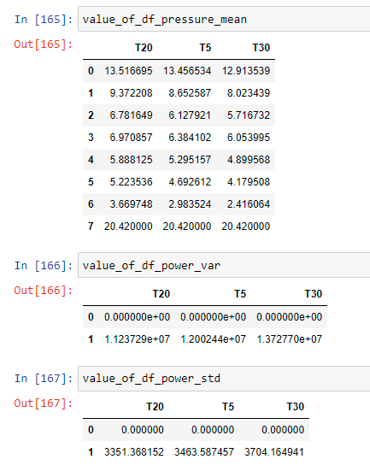

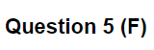
f) Investigate the importance of considering each of the three sources of uncertainty. To check this, re-run simulation while setting one uncertainty at a time to be zero and see what eﬀect that has. Report results from each case and brieﬂy discuss your observations on how they change from your results in part d) and from case to case (i.e. which uncertainty has the most signiﬁcant eﬀect?).
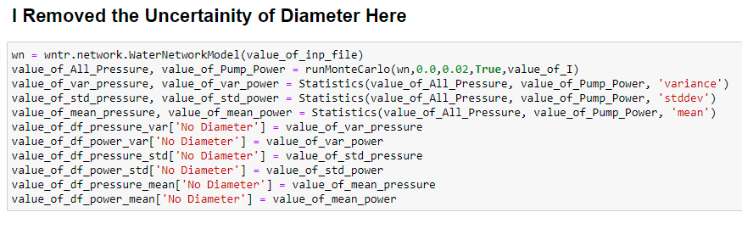
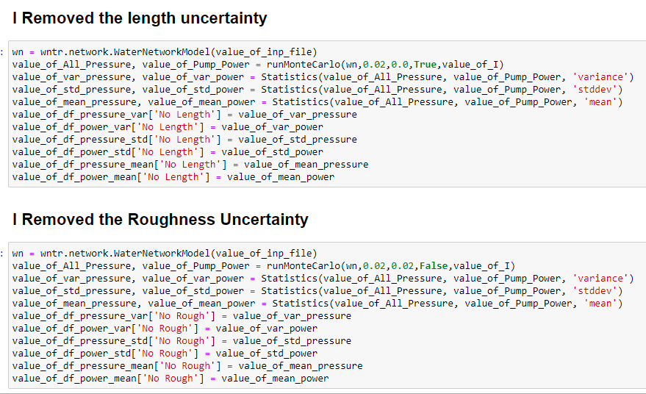
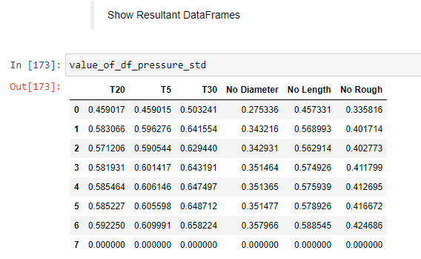
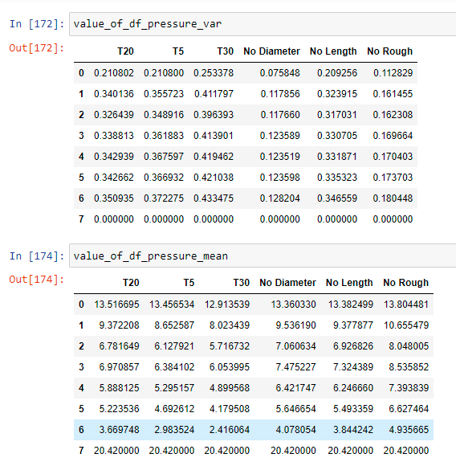
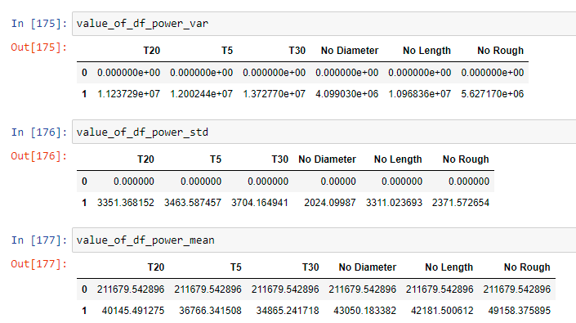

Question 5 (G)

g) Within each pipe, calculate viscous length scale (SSA will provide example upon request), wall shear stress and estimate if a super hydrophobic coating with damage threshold of 10 Pa of shear and manufactural with rams roughness of 100 µm might result in drag reduction in each pipe segment (Requires having roughness below ∼ 5 viscous length scales. For simplicity: assume that there would be a way to avoid entrainment of gas from the surface into the ﬂow and a way to supply gas to the surface at pipeline pressure – not necessarily achievable presently).

